Process Improvement
Plan
Version 1.0



Luminous Infoways Pvt. Ltd.
Address: N6-373, IRC Village,
Bhubaneswar - 751 015, Odisha, India
Phone: +91 674 2360573, +91 674 6451236
Fax: 91 674 2360724
Web: http://luminousinfoways.com
Revision History
Version (x.y) | Revision Date | Description of Change | Reason for Change | Affected Sections | Author / Modifier
1.0 | 12/01/2016 | Initial Draft | Process Improvement Plan | All | Satyakam Misra

Approval History
Version (x.y) | Prepared By | Reviewed By / Date | Approved By / Date
1.0 | Satyakam Misra | Tanmay Mohanty / 13/01/2016 | Tanmay Mohanty / 13/01/2016

Table of Contents
Revision History i
Approval History i
Table of Contents ii
1. Purpose 1
2. Scope 1
2.1 Reference Documents 1
2.2 Target Audience 1
3. Project Organization 1

4. Process Management Groups 2
4.1 SEPG Team 2
4.2 IQA Team 2

5. Road Maps & Initiatives 2

6. Quality Objectives 3

7. Project Methodology 3

8. Estimation 3

9. Activities Planned 4

10. Schedule 4
11. Resource Plan 5
11.1 Hardware Requirements 5
11.2 Software Requirements 5
11.3 Tools Requirement 5
11.4 Critical Resource Tracking 5
12. Training Plan 5

13. Risk Management Plan 6

14. Project Progress Tracking 7
14.1 Progress Reporting & Team Meetings 7
14.2 Issues & Action Item Tracking 8
14.3 Project Closure 9

15. Plan Revision Criteria 8

Purpose
The purpose of this document is to describe the approach for continued software development process improvement during the life cycle of projects in Luminous Infoways Pvt. Ltd. The document identifies the specific actions that will be taken to improve the software process, and outlines the plans for implementing those actions.

Scope
The scope of this document will include all the key business areas. These would include:
- Testing and Validation
- Organizational Training
- Configuration Management
- Supplier Agreement Management
- Requirements management
- Technical solution
- Project Management
The process improvement plan will start along with the starting of a project. As and when a key improvement area is identified, it will be documented and proper suggestions for improvements will be given. The suggestions will be analyzed and tracked so that they help in improvement of these processes. When the suggested process is implemented the improvement process for that area will end.

Reference Document
- Process Area Library (PAL) Guidelines v 1.0
- Process Tailoring Guidelines v 1.0
- Organization Process Focus Policy v 1.0
- Quality Management System Improvements Procedure v 1.0

Target Audience
The target audiences for process improvement plan are customers of the company and at the same time the shareholders of the company. A process improvement plan is meant to improve the efficiency of key business areas thereby helping in cutting down costs, efforts and time. This is intended to benefit both the clients as well as the employees of the company.

Project Organization
Luminous Infoways Pvt. Ltd.

Process Management Groups

SEPG Team
Sl. No. | Resource Name | Designation
1 | Tanmay Mohanty | CEO
2 | Debasish Mishra | Project Manager
3 | Satyakam Misra | System Analyst
4 | Mausumi Panda | QC
5 | Samadhan Mishra | System Architect

IQA Team
Sl. No. | Resource Name | Designation
1 | Girija Shankar Mohapatra | Project Manager
2 | Bibek Panigrahi | Team Lead
3 | Satyakam Misra | System Analyst
4 | Debasish Mishra | Project Manager

Road map & Initiatives

Develop a road map that is well understood and accepted by the identified process owners.

Key consideration for road map includes:

1. Project Size and complexity:

This is an important factor in creating the road map, as it helps companies gauge the effort required for each project and aggregate the processes into for execution.

2. Project interdependencies:

All project inter dependencies must be captured.

3. Change impact:

Change impact should be defined. Identifying the consequences of a change, or estimating what needs to be modified to accomplish a change.

Quality Objectives
- Understand existing processes. Analyze and understand the environment. Need to understand current processes before improvement.
- NC should not arise against audits.

- Introducing process changes to achieve organizational objectives which are usually focused on quality improvement, cost reduction and schedule acceleration.

- Based on goals, processes, methods, and tools have to be determined.

- Execute the process– Perform the processes constructing the required products.

- Analyze– At the end of each project, analyze the data gathered, determine problems, and make recommendations for improvement.

- Package– Structure knowledge and store it an experience base for future re use.

Project Methodology

- Establish top level work break down structure (WBS) to estimate the scope of the project.

- Establish and maintain estimates of the attributes of the work products and tasks.

- Define the Project life cycle phases upon which to scope the planning effort.

- Establish and maintain the project's budget and schedule.

- Plan for necessary resources to perform the project.

- Establish and maintain the overall project plan.

- Obtain commitment from relevant stakeholders responsible for performing and supporting plan execution.

- Identify and analyze the project risks.

- Plan for knowledge and skills needed to perform the project.

Estimation
Review meeting shall be conducted once in every six months with the SEPG team.
Meeting duration shall be 2 hours.
Meeting dates to be declared 1 month before the meeting.

Activities Planned
- Define the High Level features of the project.

- Estimate the difficulty/complexity of a project

- Define the Project life cycle.

- Estimate the billable hours.

- Estimates of what work will be done for each release.

Schedule
Once in every six months review meeting shall be conducted.

Resource Plan

Hardware Requirements
- Meeting Room
- PC for each meeting attendee

Software Requirements
- MS Office

Tools Requirement
Not applicable.

Critical Resource Tracking
- Availability of human resources
- Proper infrastructure for meeting
- Availability of internet connection
- Knowledge on the current processes being followed on an organization level

Training Plan
QMS training shall be provided.

Risk Management Plan
Risk-Based, Requirement- Driven Testing Approach:

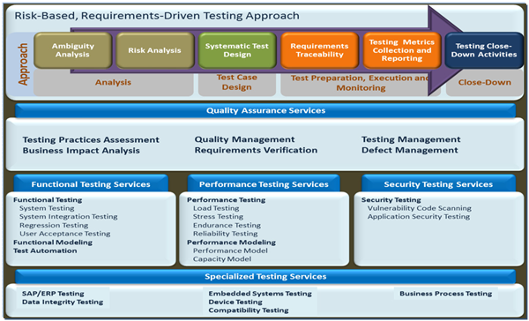

Risk Management Architecture

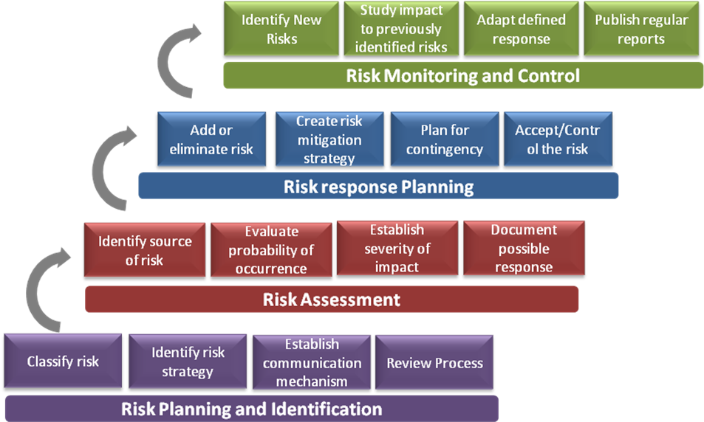

Project Progress Tracking

Progress Reporting & Team Meetings
Internal Weekly Review Meetings
Project Manager conducts weekly review meeting of the entire project team. Following points are discussed during the meeting:
- Work done – This is matched against the project plan. Any delays and the reasons for delays are discussed
- Plans for next week
- Any highlight of the week – this may be related to delay or some achievement
- Any dependency – this may include dependency on some other member of the team, resource availability, and information to be provided by customer etc.
- Time sheets for the week are handed over to the project manager during this meeting. Project manager consolidates and sends a complete report to the client.

Monthly Progress Reports summarizing
- Results accomplished during the period
- Cumulative deviations to date from schedule of progress on milestones
- Corrective actions to be taken to return to planned schedule of progress
- Proposed revisions to planned schedule
- Other issues and outstanding problems, and actions proposed to be
taken

Periodic Review Meeting with client
Periodic review of the project is done with the customer. The frequency of this periodic review is decided at the start of the project and frequency may be changed if both the parties agree. As described in the previous section, a weekly report is sent to the customer. This report clearly depicts the progress of the project and any areas of concern.

Issues & Action Item Tracking
Monitoring Team Review
Our organization forms a Project Monitoring Team to control and monitor the progress of any Project. This team usually consists of following members:
- Representatives from Customers; usually the Customer’s Project Manager, representatives from the Customer’s User organization/ division/ department
- Project Manager of our Project Team.
- Representative from our Quality Assurance Organization
The frequency of this meeting is very less. This meeting is generally done once every month. It may be held earlier if the situation requires this because of some unforeseen situations. One week prior to the full Monitoring Team meeting, the Project team also reviews the project status with our Project Manager.
Luminous Infoways will be kept updated with the progress of the project. Any deviations from the agreed milestones are communicated to the customer well in advance. Similarly the customer is also expected to communicate to our Project Team any changes in specifications at the earliest.

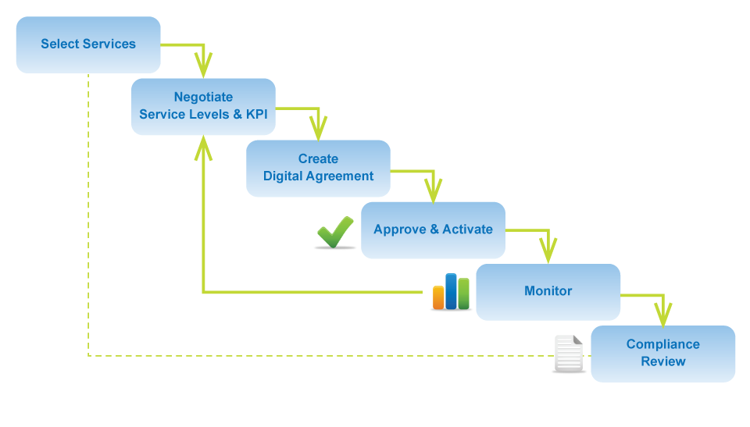 SLA Management Process

Project Closure
Project closure report shall be created at the end of the project which shall contain information such as project's best practices, project feedback, lessons learnt, suggestions for improvement, etc.

Plan Revision Criteria
- Shift in strategy
- Project progress not as per schedule
- Change in Resource Plan

